In the early 1850s, people began immigrating to the United States from China. The first waves of immigrants found jobs working in the gold mines, building railroads, operating restaurants and shops, and in agriculture. They faced racism, harassment, and discrimination and formed communities to help people find jobs, learn English, find places to live, worship together, and combat discrimination.
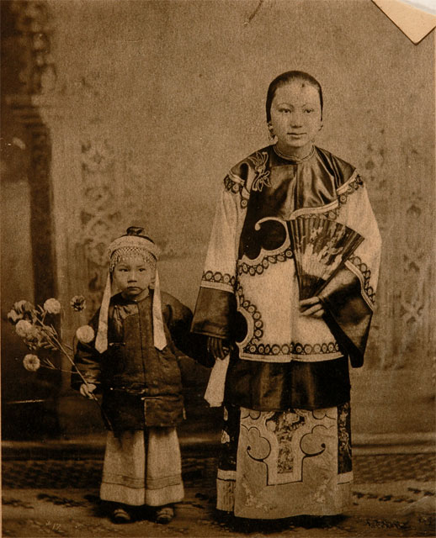
http://collections.theautry.org/mwebcgi/mweb.exe?request=record;id=M23073;type=102
Object Name: Photograph
Maker: Unidentified photographer
Title: A Family Portrait in San Francisco’s Chinatown
Date: early 1800s
Object ID: P.14024
Notes: Photograph of a mother and child posing for a family portrait in Chinatown, San Francisco.
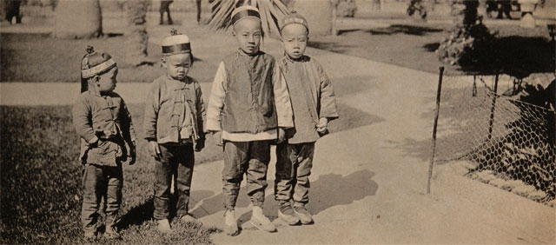http://collections.theautry.org/mwebcgi/mweb.exe?request=record;id=M23011;type=102
Object Name: Photograph
Maker: Unidentified photographer
Title: A Group of Young Chinese Boys
Date: early 1800s
Object ID: P.14013
Notes: Photograph of a group of four boys in Chinatown, San Francisco.

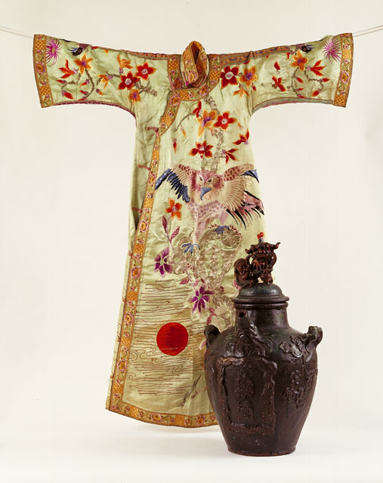
http://collections.theautry.org/mwebcgi/mweb.exe?request=record;id=M534451;type=101
Object name: Jar
Date: 1800s
Object ID: 94.70.5
Notes: Chinese Shiwan earthenware medicine steeping jar.
Object name: Robe
Date: late 1800s to early 1900s
Object ID: 94.236.1
Notes: Women’s embroidered, pale green silk robe.

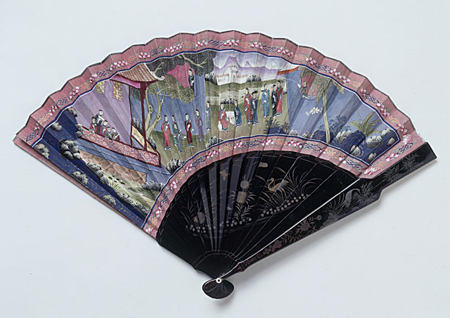
http://collections.theautry.org/mwebcgi/mweb.exe?request=record;id=M577781;type=101
Object name: Fan
Date: 1860s
Object ID: 2002.1.20
Notes: Canton Chinese fan made from wood, ivory, and paper. This is typical of the kind of fan made for export and was owned by the Vallejo family from Sonoma, California.

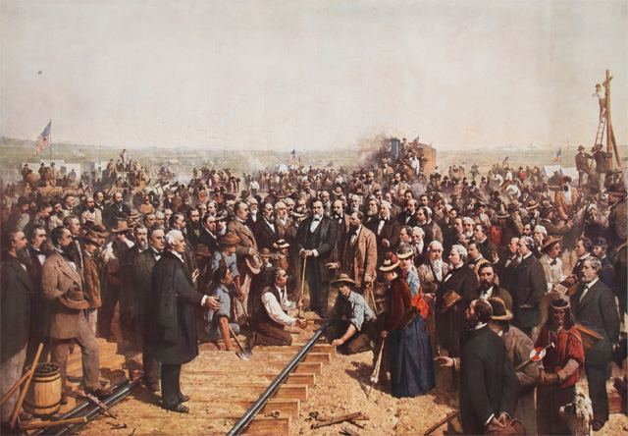
http://collections.theautry.org/mwebcgi/mweb.exe?request=record;id=M77146;type=101
Object Name: Poster
Maker: Thomas Hill
Title: Driving of the Last Spike (Gold) at the Joining of the Central and Union Pacific Lines - Promontory, Utah, May 10, 1869
Date: circa 1881
Object ID: 14.C.1202
Notes: Leland Stanford, the Civil War Governor of California and one of the founders of the Central Pacific Railroad, commissioned California painter Thomas Hill to paint a monumental portrait of the ceremony at Promontory Point, Utah. The image mingled fact and fiction. Stanford directed who would be included among the portraits. People who were not present at the 1869 ceremony were included, while the Chinese workers who laid the last rails to Promontory Point were erased.

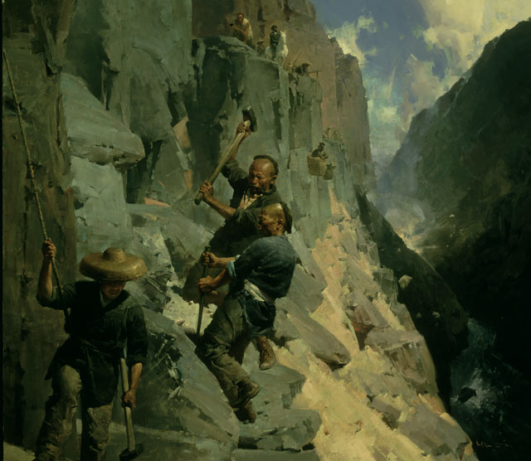
http://collections.theautry.org/mwebcgi/mweb.exe?request=record;id=M579493;type=101
Object Name: Painting
Maker: Mian Situ
Title: Powder Monkeys, Transcontinental Railroad, Cape Horn, 1865
Date: 2001–2002
Object ID: 2002.3.1
Notes: Oil painting depicting Chinese railroad workers on the side of a mountain chipping away granite. Above and in the background, there are more workers—some are being lowered in baskets. On the right of the painting there is an explosion in the distance and a river winds down between two mountains.

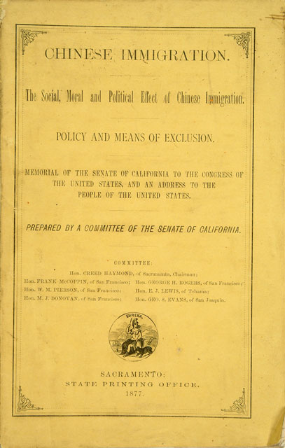
http://collections.theautry.org/mwebcgi/mweb.exe?request=record;id=ocm16075850;type=106
Object: Pamphlet
Title: Chinese immigration the social, moral and political effect of Chinese immigration. Policy and means of exclusion.
Maker: California State Legislature, Senate Special Committee on Chinese Immigration.
Date: 1877
Object ID: 94.93.1
Notes: This pamphlet lays out the act passed by the California State Legislature to exclude Chinese immigrants in 1877 prior the U.S. Congress passage of the Chinese Exclusion Act of 1882.

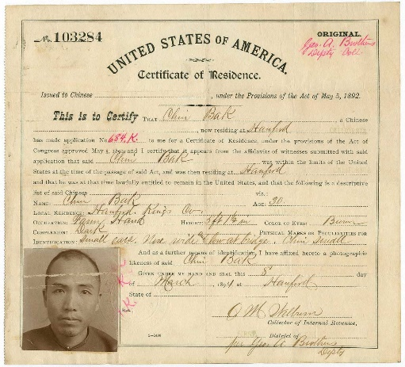
http://collections.theautry.org/mwebcgi/mweb.exe?request=record;id=M560754;type=105
Object Name: Document
Title: “Certificate of Residence”
Date: 1894
Object ID: 87.59.356
Notes: Certificate of residence for Chin Bak, issued in Hanford, California, on March 1894. On September 19, 1892, California passed the Geary Act. The law extended the Chinese Exclusion Act of 1882 for ten years and required Chinese residents in California to carry photo identification proving they were legal immigrants.

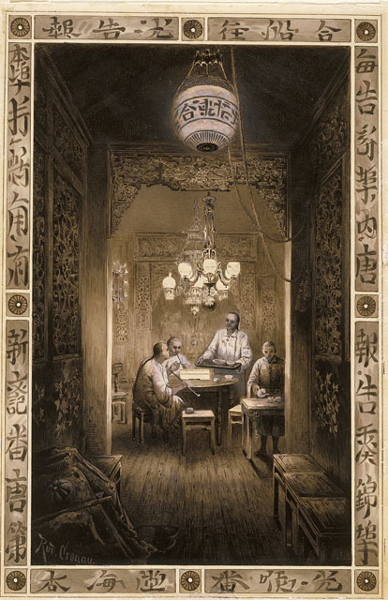http://collections.theautry.org/mwebcgi/mweb.exe?request=record;id=M560883;type=101
Object name: Drawing
Maker: Rudolf Cronau
Title: A Chinese Teahouse, San Francisco
Date: 1880s
Object ID: 93.99.3
Notes: Pen and ink drawing featuring four Chinese people seated at a table in a teahouse located in Chinatown, San Francisco.

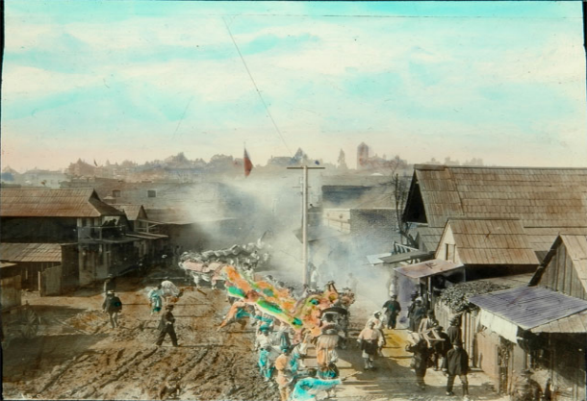http://collections.theautry.org/mwebcgi/mweb.exe?request=record;id=M14579;type=102
Object Name: Lantern Slide
Title: Parade with Dragon through Old Chinatown
Date: late 1800s
Object ID: LS.12344
Notes: A lantern slide of a dragon in a parade through Old Chinatown in Los Angeles. Lantern slides are photographs made on glass and viewed with an early version of a projector.
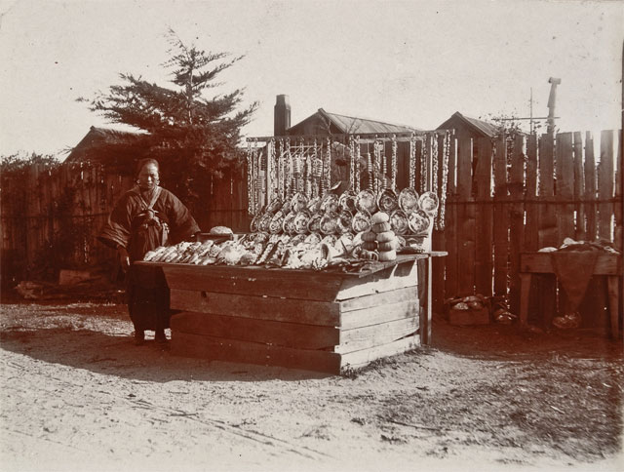
http://collections.theautry.org/mwebcgi/mweb.exe?request=record;id=M17120;type=102
Object Name: Lantern Slide
Maker: Unidentified photographer
Title: The Chinese Shell Vendor
Date: early 1900s
Object ID: P.12769
Notes: Photograph of a Chinese shell vendor in Carmel, California.
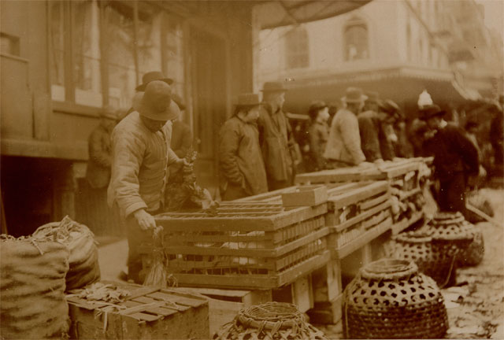http://collections.theautry.org/mwebcgi/mweb.exe?request=record;id=M23040;type=102
Object Name: Photograph
Maker: Unidentified photographer
Title: A Chicken Vendor in San Francisco’s Chinatown
Date: circa 1892
Object ID: P.14018
Notes: Photograph of a chicken vendor in Chinatown, San Francisco.

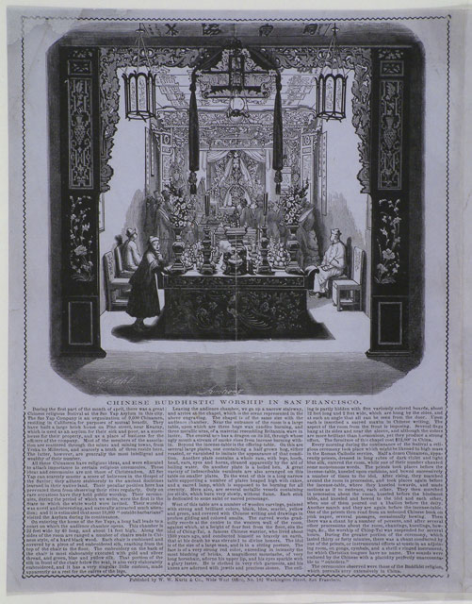
http://collections.theautry.org/mwebcgi/mweb.exe?request=record;id=M524666;type=105
Object Name: Lettersheet
Maker: Charles Christian Nahl, published by W.W. Kurtz & Company
Title: Chinese Buddhistic Worship in San Francisco
Date: 1855
Object ID: 94.237.10
Notes: A lettersheet featuring the interior of a Chinese Buddhist temple in San Francisco. Printed below is an article about a religious festival held at the Sze Yap Asylum, headquarters for poor and sick members of the Chinese community in California.

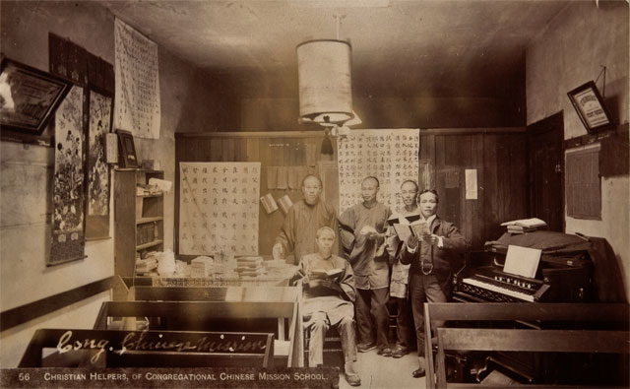
http://collections.theautry.org/mwebcgi/mweb.exe?request=record;id=M17107;type=102
Object Name: Photograph
Maker: Unidentified photographer
Title: Christian Helpers of Congregational Chinese Mission School
Date: early 1900s
Object ID: P.12766
Notes: Photograph of a group of Chinese men at the Mission School, San Francisco, California.

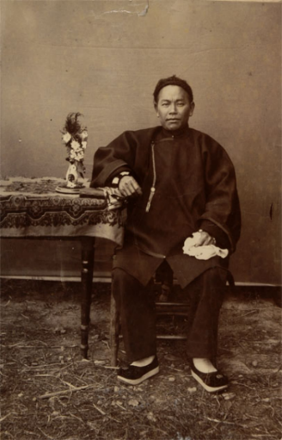
http://collections.theautry.org/mwebcgi/mweb.exe?request=record;id=M17098;type=102
Object Name: Photograph
Maker: Unidentified photographer
Title: A Portrait of an Unidentified Chinese Man
Date: early 1900s
Object ID: P.12764
Notes: Photograph of an unidentified Chinese man in California.
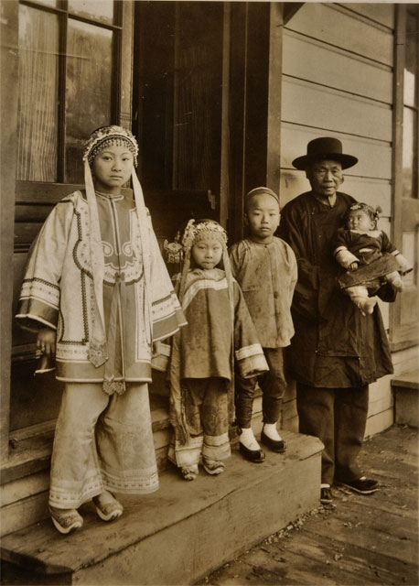
http://collections.theautry.org/mwebcgi/mweb.exe?request=record;id=M17110;type=102
Object Name: Photograph
Maker: Unidentified photographer
Title: A Chinese Family in California
Date: early 1900s
Object ID: P.12767
Notes: Photograph of an unidentified Chinese family in California.

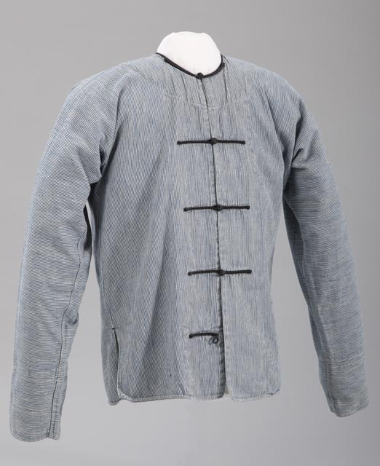
http://collections.theautry.org/mwebcgi/mweb.exe?request=record;id=M514609;type=101
Object name: Jacket
Date: circa 1900
Object ID: 94.76.1
Notes: Chinese cotton jacket, worn by a Chinese railroad worker.

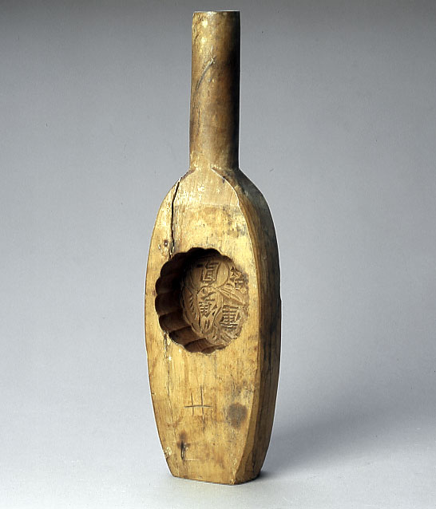
http://collections.theautry.org/mwebcgi/mweb.exe?request=record;id=M517838;type=101
Object name: Cake mold
Date: circa 1900
Object ID: 94.70.1
Notes: Used to make sweets like moon cakes. Carrying on a centuries-old tradition, Chinese women offered these cakes to relatives and friends as part of mid-autumn festivities celebrating family unity.

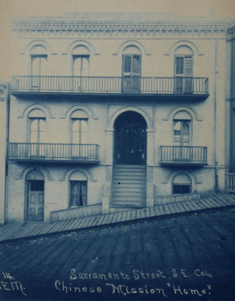http://collections.theautry.org/mwebcgi/mweb.exe?request=record;id=M17102;type=102
Object Name: Photograph
Maker: H.E. Matthews
Title: The Chinese Mission Home on Sacramento Street, San Francisco, California
Date: early 1900s
Object ID: P.12765
Notes: A photograph of the Chinese Mission Home in San Francisco, California.
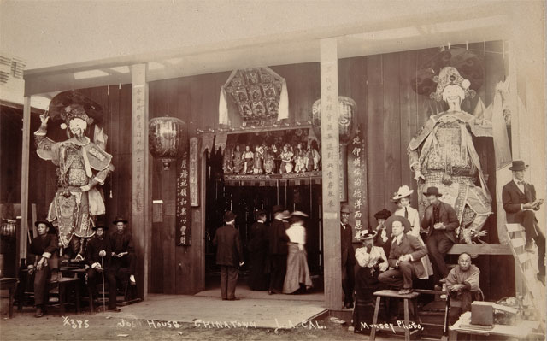http://collections.theautry.org/mwebcgi/mweb.exe?request=record;id=M31197;type=102
Object Name: Photograph
Maker: Munsey
Title: A “Joss House” in Old Chinatown Sections Los Angeles
Date: early 1900s
Object ID: P.15740
Notes: A Joss House is a place of worship.

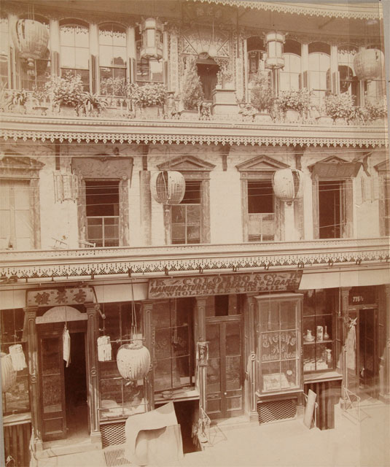http://collections.theautry.org/mwebcgi/mweb.exe?request=record;id=M23914;type=102
Object Name: Photograph
Maker: Taber
Title: A Chinese Restaurant on Dupont Street, San Francisco
Date: early 1900s
Object ID: P.14160
Notes: Photograph of a street scene in Chinatown, San Francisco.
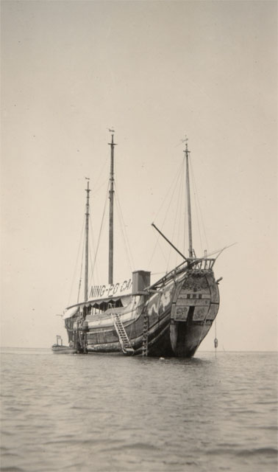
http://collections.theautry.org/mwebcgi/mweb.exe?request=record;id=M46643;type=102
Object Name: Photograph
Maker: Harry Vroman
Title: Old Chinese Junk, Ning-Po
Date: circa 1913
Object ID: A.184.235
Notes: Photograph of Ning-Po, a Chinese junk vessel, Avalon, Santa Catalina Island, California.

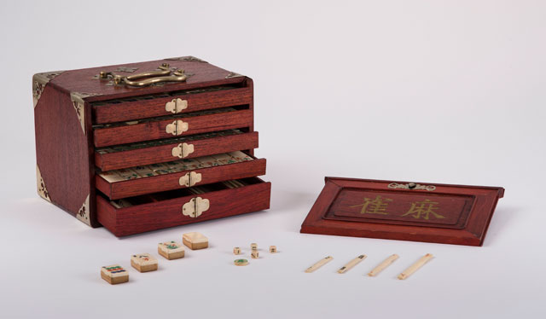
http://collections.theautry.org/mwebcgi/mweb.exe?request=record;id=M539813;type=101
Object name: Mah-jhong (set)
Maker: Unknown artist
Date: 1920s
Object ID: 93.123.1
Notes: Chinese mah-jhong is a tile-based game developed in China in the 1800s.

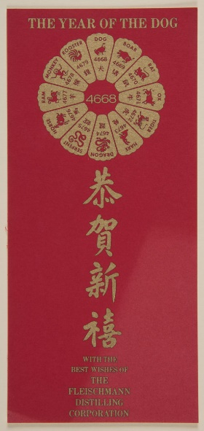
http://collections.theautry.org/mwebcgi/mweb.exe?request=record;id=M663097;type=102
Object Name: Brochure
Title: “Year of the Dog”
Date: 1970
Object ID: 2016.0.30
Notes: Chinese calendar logo for Year of the Dog in year 4668 (1970).

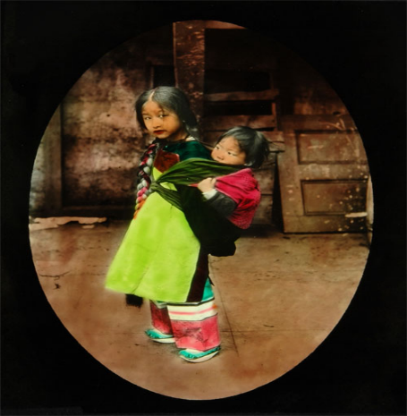
http://collections.theautry.org/mwebcgi/mweb.exe?request=record;id=M277606;type=102
Object Name: Lantern Slide
Maker: Unidentified photographer
Title: Chinese Children in San Francisco
Date: Late 1800s
Object ID: LS.3094
Notes: Lantern slide of Chinese children in San Francisco. Lantern slides are photographs made on glass and viewed with an early version of a projector.
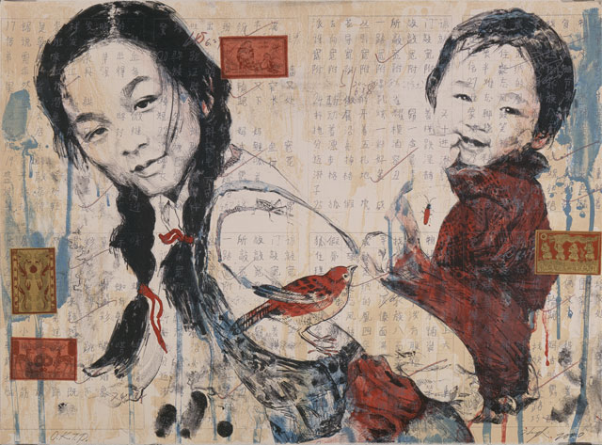
http://collections.theautry.org/mwebcgi/mweb.exe?request=record;id=M581008;type=101
Object Name: Print
Maker: Hung Liu
Title: Sisters
Date: 2000
Object ID: 2002.41.3
Notes: A lithograph by artist Hung Liu.

