During the Civil War, a group of African American men wanted to join and fight for the Union Army. Congress approved the formation of African American troops, and more than 180,000 men enlisted. The first troop formed was the Massachusetts 54th Regiment, which began recruiting in February 1863. Men from across the country joined the regiment—some as young as 16. The soldiers fighting in the Massachusetts 54th and other African American regiments were paid less than their white counterparts and they received lower-quality equipment and supplies. Yet, these soldiers fought bravely and helped the Union Army win the war. After the Civil War, Congress created six African American regiments to serve in the American West; these troops came to be known as the Buffalo Soldiers. The following artifacts were used by or connect to African American regiments during the Civil War and Reconstruction era.

Object images and descriptions are on next page with hyperlinks to the objects on Autry Collections.

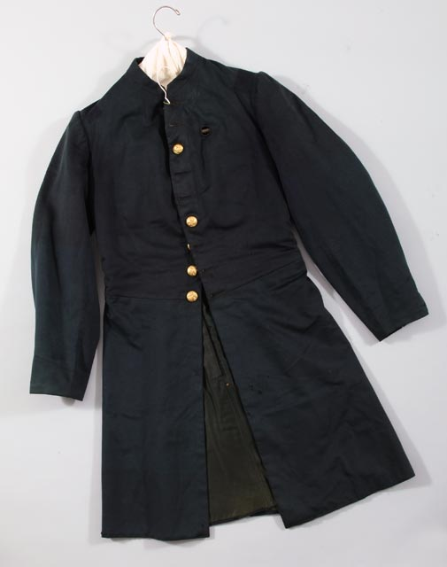
http://collections.theautry.org/mwebcgi/mweb.exe?request=record;id=M207795;type=101
Object Name: Coat
Maker: Unknown
Date: 1862-1864
Object ID: 40.G.8
Notes: A wool cloth coat, part of the infantry uniform, worn by Lt. David Grant Cooke in Company F of the 12th U.S. Colored Troops.

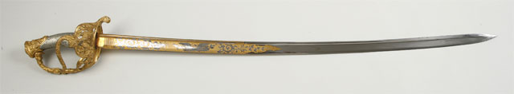
http://collections.theautry.org/mwebcgi/mweb.exe?request=record;id=M532505;type=101
Object Name: Sword and scabbard
Maker: William H. Horstmann
Title: Cavalry 1860 presentation model
Date: circa 1870
Object ID: 89.215.1
Notes: A 7th Cavalry 1860 model of a presentation sword and scabbard. Presented to Lt. Charles C. De Rudio, an Italian immigrant and officer in the 2nd U.S. Colored Infantry during the Civil War.
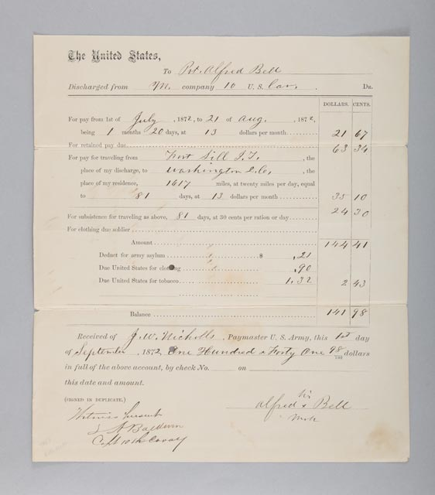
http://collections.theautry.org/mwebcgi/mweb.exe?request=record;id=M567114;type=105
Object Name: Document
Maker: U.S. Army
Date: 1872
Title: Discharge certificate for Private Alfred Bell, 10th Cavalry
Object ID: 93.142.2
Notes: Discharge certificate for Private Alfred Bell, soldier in the 10th Calvary, an African American troop the U.S. Army, on September 1, 1872. A discharge is a complete release from the military and your duties.

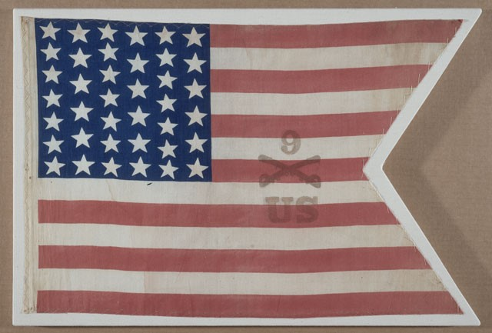
http://collections.theautry.org/mwebcgi/mweb.exe?request=record;id=M519261;type=101
Object: Flag
Maker: Unknown
Title: Parade Flag of the 9th Cavalry
Date: 1875-1900
Object ID: 2002.91.1
Notes: Flag of United States, red, white and blue cotton with thirty-nine stars, circa 1876-1900. This flag was used by the 9th U.S. Cavalry, an African American regiment in the West, as a parade flag.

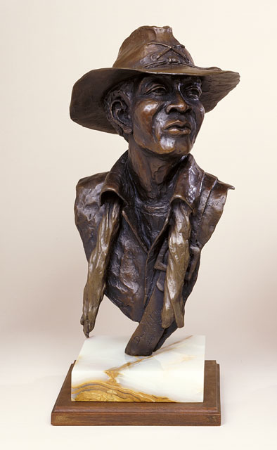
http://collections.theautry.org/mwebcgi/mweb.exe?request=record;id=M570368;type=101
Object Name: Sculpture
Maker: Ed Dwight
Title: Buffalo Soldier
Date: circa 1981
Object ID: 99.29.1
Notes: Ed Dwight’s bronze, wood, and marble sculpture, entitled Buffalo Soldier, a nickname for African American soldiers who served in the West after the Civil War.

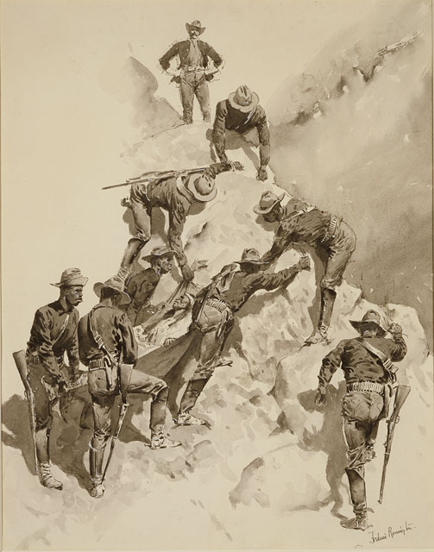
http://collections.theautry.org/mwebcgi/mweb.exe?request=record;id=M524793;type=101
Object Name: Drawing
Maker: Frederic Remington
Title: Leaving the Canyon (10th Cavalry soldiers with wounded Apache)
Date: 1887
Object ID: 88.108.26
Notes: Frederic Remington’s drawing Leaving the Canyon (10th Cavalry soldiers with wounded Apache) depicts some of the men in the 9thand 10th U.S. Calvary, troops of African American soldiers.

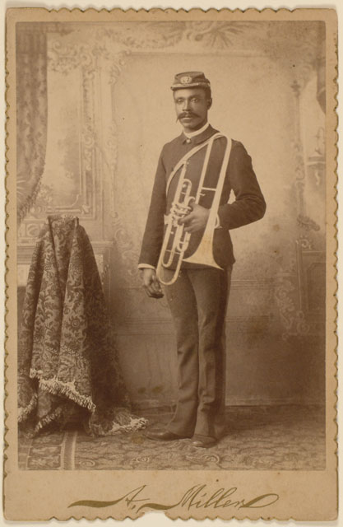
http://collections.theautry.org/mwebcgi/mweb.exe?request=record;id=M512748;type=102
Object Name: Photograph
Maker: A. Miller
Date: February 6, 1892
Title: Untitled
Object ID: 90.103.1
Notes: Cabinet card of Wesley Porter, a musician and solider in the 10th United States Cavalry, a troop of African American soldiers. A cabinet card is a photograph attached to a piece of cardboard.

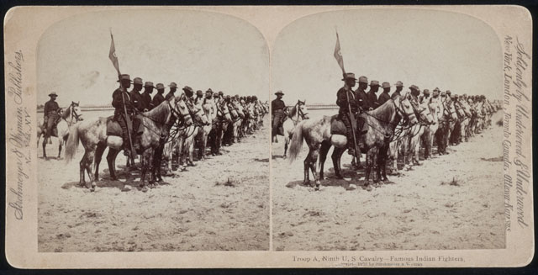
http://collections.theautry.org/mwebcgi/mweb.exe?request=record;id=M556248;type=102
Object Name: Photograph
Maker: Strohmeyer & Wyman
Date: 1898
Object ID: 93.168.2
Notes: This is a stereoview of Troop A, Ninth United States Cavalry, a troop of African American soldiers. A stereoview is a set of two nearly identical photographs.

