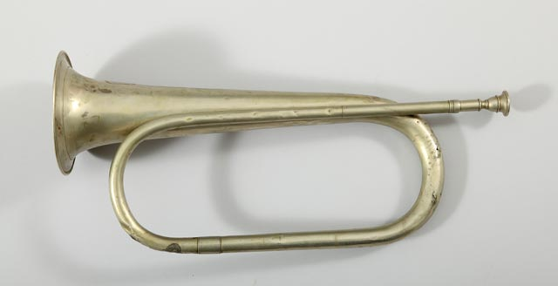
http://collections.theautry.org/mwebcgi/mweb.exe?request=record;id=M559666;type=101
Object name: bugle
Maker: N/A
Date: mid-1800s
Object ID: 89.76.8
Notes: Bugles or trumpets were used as signals by the United States military. Soldiers' daily lives were regulated by bugle calls, indicating times to rise in the morning, report for duty or meals, and retire at night.
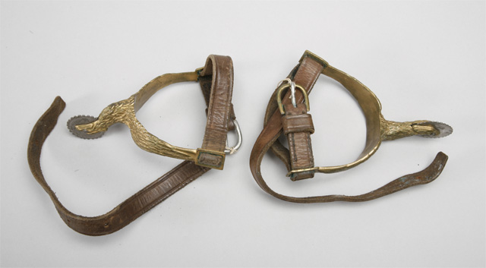
http://collections.theautry.org/mwebcgi/mweb.exe?request=record;id=M657778;type=101
Object Name: stirrup (pair)
Date: 1860s
Object ID: 138.G.16-.17
Notes: Stirrups with spurs, a pair, brass and leather, used by U.S. and Union Major General Charles Forman, 1860s.
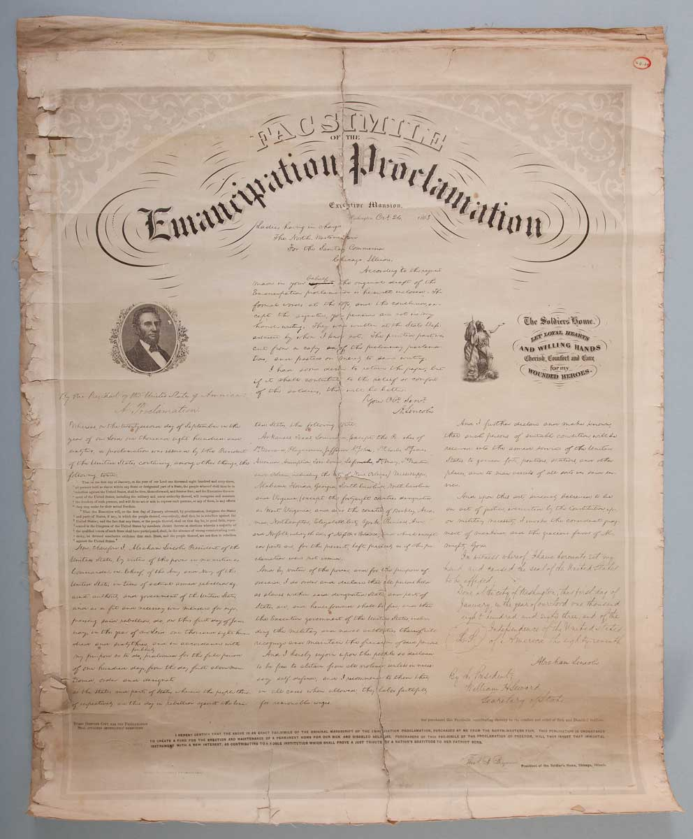
http://collections.theautry.org/mwebcgi/mweb.exe?request=record;id=M623308;type=102
Object name: documents
Title: Facsimile of the Emancipation Proclamation
Maker: Abraham Lincoln
Date: circa 1864
Object ID: 76.G.64
Notes: Facsimile or copy of the Emancipation Proclamation.
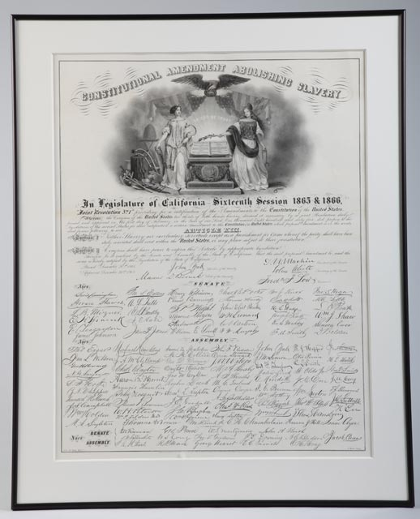
http://collections.theautry.org/mwebcgi/mweb.exe?request=record;id=M572792;type=102
Object name: poster, handbill
Title: Constitutional Amendment Abolishing Slavery
Maker: Charles Christian Nahl, Louis Nagel
Date: circa 1866
Object ID: 99.63.1
Notes: Broadside (one sheet printed and distributed) of the Legislature of California, sixteenth session, 1865 and 1866.
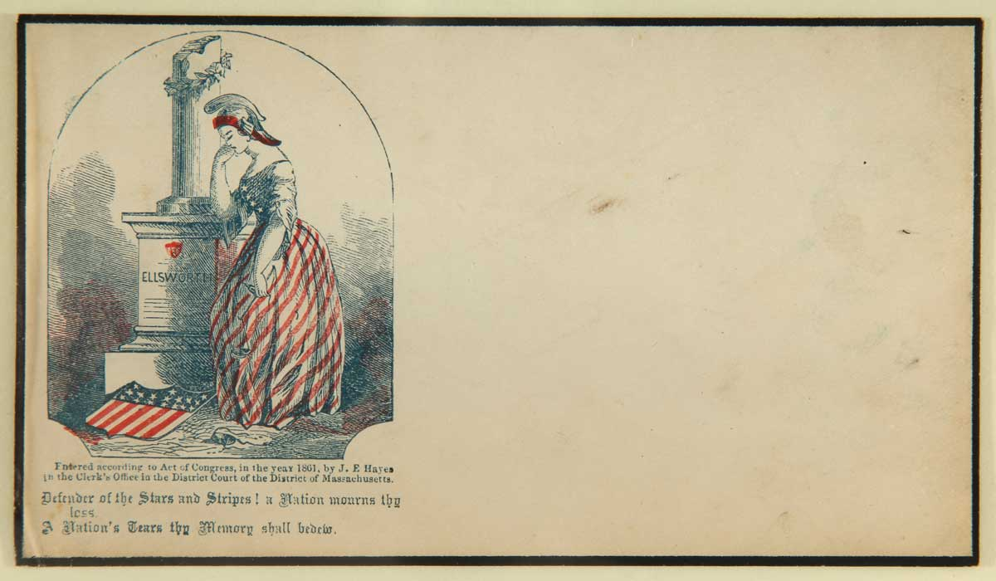
http://collections.theautry.org/mwebcgi/mweb.exe?request=record;id=M655599;type=105
Object name: envelope
Title: Defender of the Stars and Stripes: a Nation mourns thy loss. A Nation’s Tears thy Memory shall bedew.
Maker: N/A
Date: 1861
Object ID: MS.518.S2.11
Notes: Lady Liberty grieving at the grave of Col. Ellsworth. Ellsworth was killed after taking down a Confederate flag during the occupation of Alexandria, Virginia. A federal shield lies atop the grave, which might be a classical reference to Spartans who were expected come back with their shield (victorious) or on their shield (dead).

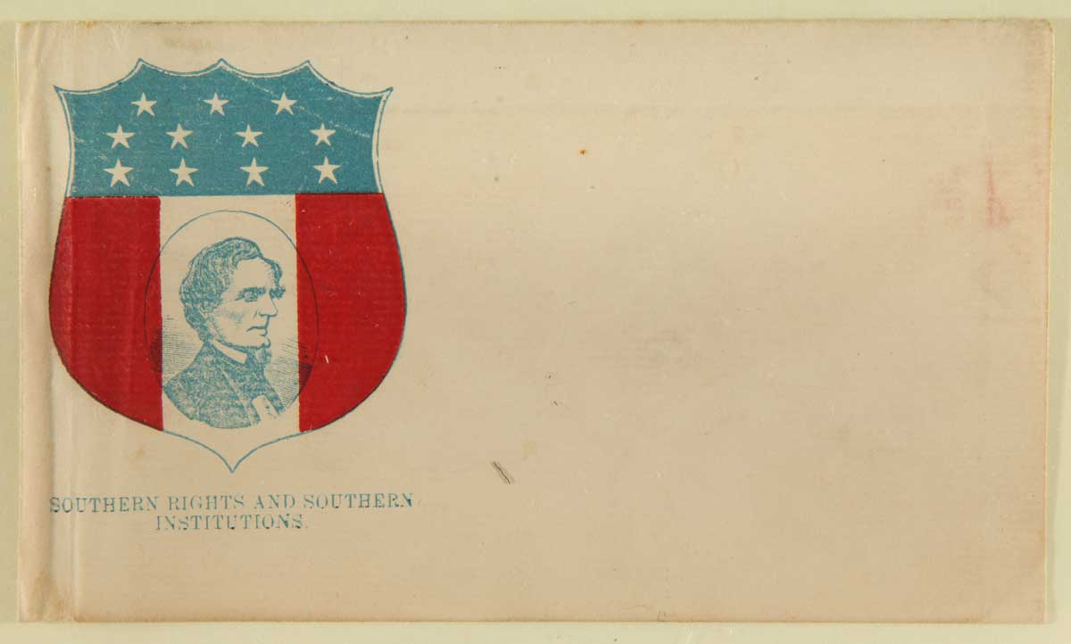
http://collections.theautry.org/mwebcgi/mweb.exe?request=record;id=M655636;type=105
Object name: envelope
Title: Southern Rights and Southern Institutions
Maker: N/A
Date: circa 1862
Object ID: MS.518.S2.48
Notes: Civil War envelope with portrait of Confederate President Jefferson Davis surrounded by patriotic symbols of the Confederacy and slogan Southern Rights and Southern Institutions.
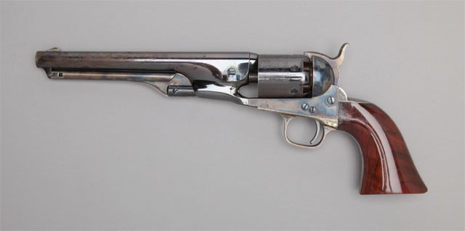
http://collections.theautry.org/mwebcgi/mweb.exe?request=record;id=M524424;type=101
Object name: revolver
Maker: Colt’s Patent Fire Arms Manufacturing Company
Date: 1861
Object ID: 87.118.24
Notes: Inscribed on backstrap: E. S. Sanford / with compliments of Col. Colt.

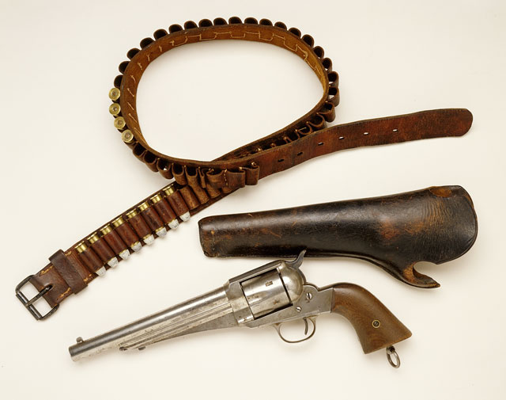
http://collections.theautry.org/mwebcgi/mweb.exe?request=record;id=M506305;type=101
Object name: gun belt, holster
Maker: N/A
Date: mid- to late 1800s
Object ID: 85.1.518
Notes: Owned by Frank James, the older brother of Jessie James. The older brother of Jesse James, Alexander Franklin “Frank” James enlisted in the Missouri Confederate State Guard soon after the firing on Fort Sumter. He left the regular army in 1863 to joined William Quantrill’s bushwhackers.

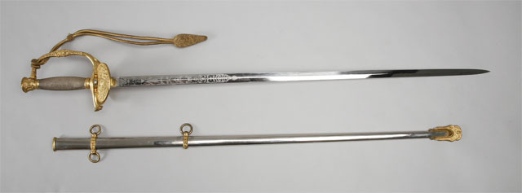
http://collections.theautry.org/mwebcgi/mweb.exe?request=record;id=M137933;type=101
Object Name: sword and scabbard
Maker: Schnitzler & Kirschbaum
Date: 1860s
Object ID: 138.G.29
Notes: Sword and scabbard, part of dress uniform of Nevada Volunteers, worn by Union Major General Charles Forman.

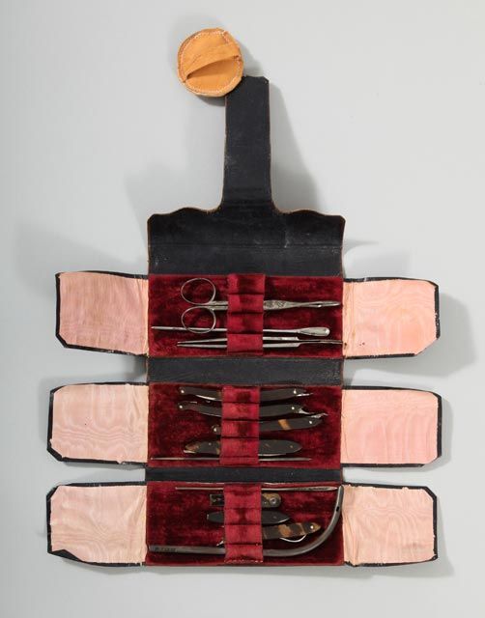
http://collections.theautry.org/mwebcgi/mweb.exe?request=record;id=M502862;type=101
Object Name: surgical kit
Maker: Dietrich W. Kolbe
Place Made: Philadelphia, PA
Date: mid-1800s
Object ID: 88.25.6

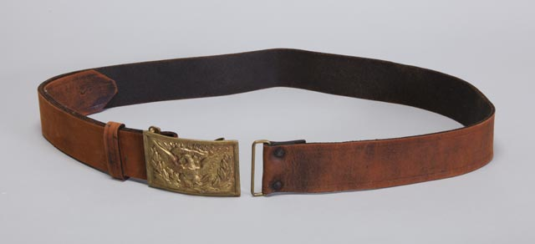
http://collections.theautry.org/mwebcgi/mweb.exe?request=record;id=M543203;type=101
Object name: belt
Maker: N/A
Date: circa 1860-1865
Object ID: 85.7.3
Notes: Belt for saber with officer's buckle, used by Union General, George A. Custer, circa 1860-1865.
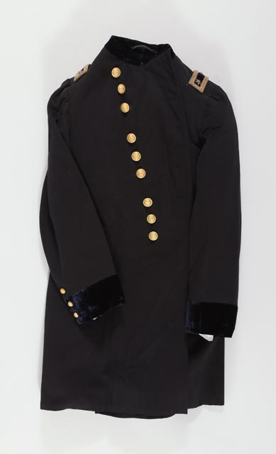
http://collections.theautry.org/mwebcgi/mweb.exe?request=record;id=M137915;type=101
Object name: coat
Maker: N/A
Date: 1860s
Object ID: 138.G.24
Notes: Coat, part of dress uniform of Nevada Volunteers to the Union Army, worn by Major General Charles Forman.
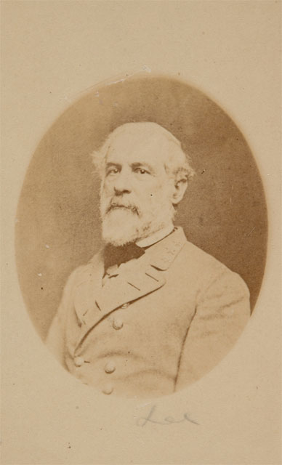
http://collections.theautry.org/mwebcgi/mweb.exe?request=record;id=M112625;type=102
Object name: photograph
Maker: O’Donnell, William D.
Date: circa 1860
Object ID: P.36323
Notes: Photograph of Union General Robert E. Lee, circa 1860.
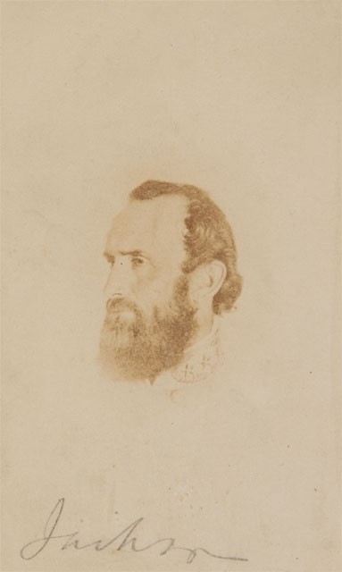
http://collections.theautry.org/mwebcgi/mweb.exe?request=record;id=M112603;type=102
Object name: photograph
Maker: O’Donnell, William D.
Date: circa 1860
Object ID: P.36318
Notes: Photograph of Confederate General, Thomas J. (Stonewall) Jackson.

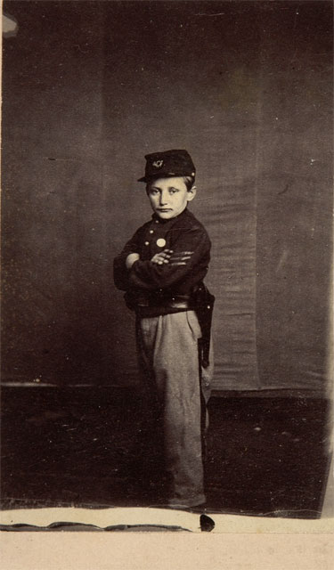
http://collections.theautry.org/mwebcgi/mweb.exe?request=record;id=M124115;type=102
Object Name: photograph
Date: 1863
Object ID: P.38836
Notes: Johnny Clem, the youngest soldier in the Army of the Cumberland, 12 years old, 1863. Caption on back of photograph tells Johnny’s story: see link.

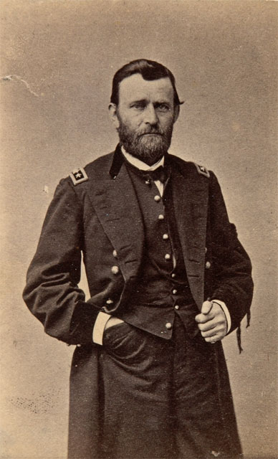
http://collections.theautry.org/mwebcgi/mweb.exe?request=record;id=M124107;type=102
Object name: photograph
Maker: unidentified photographer, Mathew B. Brady
Date: 1864
Object ID: P.38834
Notes: Photograph of Union Lieutenant General Ulysses S. Grant, photographed March 1864.

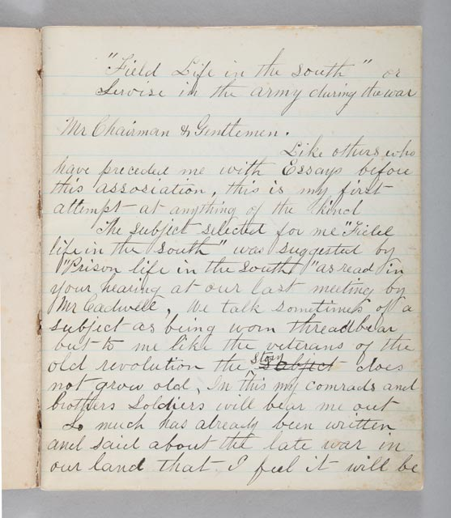
http://collections.theautry.org/mwebcgi/mweb.exe?request=record;id=M581992;type=105
Object Name: journal
Maker: Platon Vallejo
Title: Field Life in the South
Object ID: 2001.43.42
Notes: Platon Vallejo, son of Mariano Vallejo, was studying medicine at Columbia University in New York when the war broke out. He volunteered in the New York Corps of Surgeons and served on the battlefront.

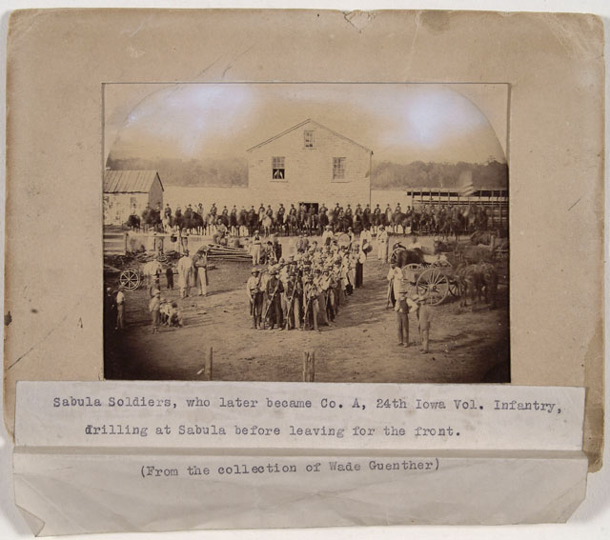
http://collections.theautry.org/mwebcgi/mweb.exe?request=record;id=M541449;type=102
Object name: photograph, mounted
Maker: United States of America (nation)
Date: circa 1861
Object ID: 90.253.1780
Notes: Photograph of drill of Sabula Soldiers, later Company A of the 24th Iowa Volunteer Infantry, Union Army.

